BACSE101 Problem Solving using Python

PROJECT REPORT
on

SilentVoice

Prepared by

ASHUTOSH CHANDRAKANTH PANDEY-25BDS0055

VISHNUVIKKAS J K R - 25BDS0242

TANMOY SAHU - 25BDS0121

SUJAL MISHRA- 25BDS0069

MOHIT PRIYAJ GHANDHI- 25BCE2604

DIVIT BOHRA- 25BDS0093

Under the supervision of
FAROOQ S.M.



School of Computer Science and Engineering
Vellore Institute of Technology, Vellore.

November 04, 2025
Table of Contents
Abstract
1. Introduction
2. Problem Statement and Objectives
3. Implementation Code
4. Demo Screenshots
5. Conclusion

Abstract

This project is a comprehensive system for American Sign Language (ASL) recognition and interpretation, combining camera-based gesture input with AI-powered language translation and speech output. The system consists of two main components: a model trainer for collecting and labeling hand sign data using computer vision (Mediapipe and OpenCV), and a live interpreter application that uses a trained neural network (MLPClassifier) to recognize ASL gestures, predict words, and translate them into multiple languages with speech synthesis. The interface offers real-time word suggestions, direct text input, and user-friendly features such as accuracy feedback, language selection, and dynamic translation, making it accessible for both data collection and interactive real-time sign language interpretation.

Introduction

Communication is one of the most essential aspects of human interaction. However, individuals with speech impairments often face difficulties in expressing themselves to people who are not familiar with sign language. To bridge this communication gap, the SilentVoice – ASL Translator project aims to translate American Sign Language (ASL) gestures into text and speech in real-time.
This project leverages computer vision and machine learning to recognize hand gestures using a webcam feed, processes them through trained models, and converts the identified gestures into meaningful words or sentences. It also integrates translation and speech synthesis to make communication smoother and more inclusive.
By combining technologies like MediaPipe, OpenCV, and Natural Language Processing (NLP), the system provides a practical and accessible tool that promotes inclusivity and empowers individuals with speech or hearing disabilities to communicate effortlessly with others.

Domain Information
- The domain centers on assistive technology that helps users with speech impairments communicate more effectively.

- 1It combines computer vision for gesture and hand sign recognition, leveraging image processing techniques.

- Artificial intelligence and machine learning models classify sign language gestures and predict intended words or phrases.

- Sign language recognition addresses a crucial need for better integration and communication for the mute people.

- The domain includes technologies such as hand landmark tracking, neural networks for classification, language translation, and speech synthesis.

- The main objective is to bridge the communication gap between sign language users and non-signers by providing real-time, accurate interpretation.

- Ongoing advancements in this field continually improve accessibility, speed, and natural interaction for assistive communication solutions.

Software Libraries Used

S.No. | Library / Module | Use / Purpose
1. | cv2 (OpenCV) | Video capture & processing
2. | mediapipe | Hand landmark detection
3. | numpy (np) | Numerical data handling
4. | tkinter | GUI creation
5. | tkinter.messagebox | Popup alerts
6. | tkinter.scrolledtext | Scrollable text box
7. | tkinter.ttk | Themed widgets
8. | PIL (Image, ImageTk) | Image display in GUI
9. | threading | Parallel processing
10. | time | Delay & timing
11. | pickle | Model saving/loading
12. | googletrans | Text translation
13. | gtts | Text-to-speech
14. | playsound | Play audio output
15. | colorsys | Color conversion
16. | nltk | Word prediction
17. | collections | Word frequency count
18. | asyncio | Asynchronous I/O operations
19. | os | File path handling
20. | csv | Data storage/export
21. | tempfile | Temporary file handling

Challenges Faced

- Lighting and Background Noise:
Poor lighting or cluttered backgrounds often interfered with accurate hand landmark detection.

- Real-Time Performance:
Ensuring smooth, lag-free gesture recognition while keeping processing fast and efficient was tough.

- Model Accuracy & Training Data:
Collecting enough quality data to train the neural network effectively required patience and repeated validation.

- Integration Complexity:
Combining multiple modules — computer vision, translation, and speech — into a seamless system took careful debugging and synchronization.

- Handling large language corpora:
Efficient management of massive text datasets for word prediction required sophisticated data structuring and optimization.

- Managing prediction context:
Ensuring accurate next-word suggestions involved real-time tracking of context and adapting predictions to user input sequences.

- Translation consistency:
Delivering reliable multi-language output was achieved by building robust algorithms that maintained correct meaning and grammar across several languages.

- Asynchronous translation errors:
The team handled unpredictable issues with real-time translation API calls, implementing error-catching mechanisms and fallback strategies to keep the system responsive.

- Integration Complexity:
Combining multiple modules—computer vision, translation, and speech—into a seamless end-to-end system required careful debugging, rigorous testing, and constant synchronization across interfaces.

2. Problem Statement and Objectives

Problem Statement:

Speech-impaired individuals primarily communicate using sign language, which is not commonly understood by the general public. This creates a communication barrier, making daily interactions difficult.

Objectives:

- Develop a system to recognize ASL hand gestures using a webcam.
- Train a neural network to classify gestures accurately.
- Convert recognized gestures into text and speech.
- Translate recognized text into multiple languages.
- Provide an intuitive graphical user interface for users.

Implementation

3.1 Feature Overview- for train.py file
The project implements an American Sign Language (ASL) Model Trainer — a desktop application that allows users to:
- Collect hand-gesture data using a webcam.
- Train a neural network model (using scikit-learn’s MLPClassifier).
- Save and reuse the model for sign-language recognition.
Each feature is implemented as a separate functional module within the TrainModelGUI class and provided as a menu-driven graphical interface.
3.2 Camera Initialization and Real-Time Hand Tracking
3.2.1 Feature:
This feature activates the webcam and processes live video using MediaPipe Hands to detect and display hand landmarks in real time.
3.2.2 Purpose:
To provide users with a live preview of their hand signs and ensure accurate landmark detection before data collection.
3.2.3 Key Code:
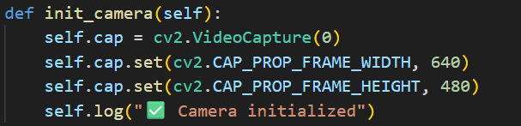

3.2.4 Explanation:
- Initializes webcam using OpenCV.
- Converts each frame from BGR to RGB for MediaPipe.
- Detects 21 hand landmarks per frame.
- Draws landmarks on the preview window for user feedback.

3.3 Data Collection Module
3.3.1 Feature:
Collects landmark coordinates for a specific ASL letter and stores them in a CSV file (asl_landmarks_data.csv).
3.3.2 Purpose:
To build a labeled dataset of hand gestures for model training.
3.3.3 Key Code:
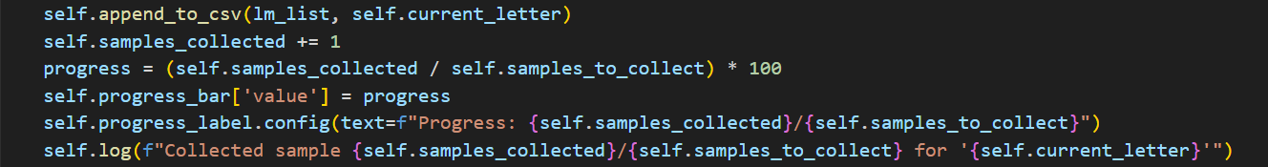
3.3.4 Explanation:
- Extracts X, Y, Z coordinates of each hand landmark.
- Appends them with the corresponding label (A–Z) to the CSV.
- Displays progress through a visual bar and logs each sample collected.
- Supports Pause, Resume, and Stop options using threading for smooth user control.

3.4 Model Training Feature
3.4.1 Feature:
Trains a machine-learning model on collected hand-landmark data.
3.4.2 Purpose:
To create a neural network capable of recognizing ASL hand signs.
3.4.3 Key Code:
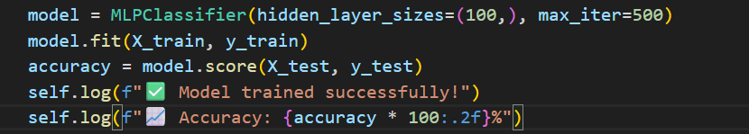
3.4.4 Explanation:
- Loads data from the CSV file.
- Encodes labels using LabelEncoder.
- Splits data into training and test sets (80-20).
- Trains an MLP (Multi-Layer Perceptron) classifier.
- Displays accuracy and saves the model to asl(1)_landmarks_model.pkl.

3.5 Graphical User Interface (GUI) Management
3.5.1 Feature:
Provides an interactive GUI for non-technical users using Tkinter.
3.5.2 Purpose:
To make model training accessible without command-line knowledge.
3.5.3 Key Code:
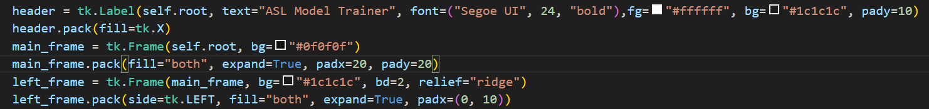
3.5.4 Explanation:
- Organized layout with frames: video preview, data collection, and logs.
- Includes real-time logs, progress bars, and message boxes.
- Menu-like buttons allow switching between data collection and training modules.
3.6 Threaded Processing
3.6.1 Feature:
Implements multithreading to handle data collection and training without freezing the GUI.
3.6.2 Key Code:
3.6.3 Explanation:
Threads ensure:
- The GUI remains responsive during long processes.
- Data collection and model training run in the background.
- Smooth user experience without lag.

3.7 Model Saving and Reusability
3.7.1 Feature:
Saves the trained model for future use.
3.7.2 Purpose:
To enable future prediction without retraining from scratch.
3.7.3 Key Code:
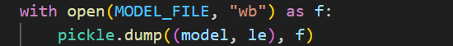
3.7.4 Explanation:
Stores both the model and label encoder in .pkl format, allowing later integration into a recognition system.

For runmodel.py file:

Features
The project SilentVoice – ASL Interpreter implements the following major features:
- Live Hand Gesture Recognition
- Word Formation and AI-based Suggestions
- Multi-Language Translation
- Text-to-Speech Output
Each of these features is implemented as an integrated module inside the Python code using machine learning, computer vision, and natural language processing techniques.
The following sections describe and demonstrate each feature in detail.

Live Hand Gesture Recognition

Objective:
To detect and classify real-time American Sign Language (ASL) hand gestures captured through the webcam.

Implementation Details:

- Libraries used: cv2, mediapipe, numpy, pickle
- Trained Model: Pre-trained ASL recognition model (asl(1)_landmarks_model.pkl)
- Process:
  - Captures real-time video from webcam using OpenCV.
  - Detects 3D hand landmarks using MediaPipe Hands.
  - Extracts 63 features (x, y, z coordinates for 21 key points).
  - Predicts the corresponding alphabet using the trained neural network model.
  - Displays recognized letters and confidence on the GUI.

Sample Code Snippet:

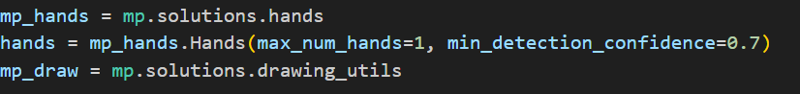

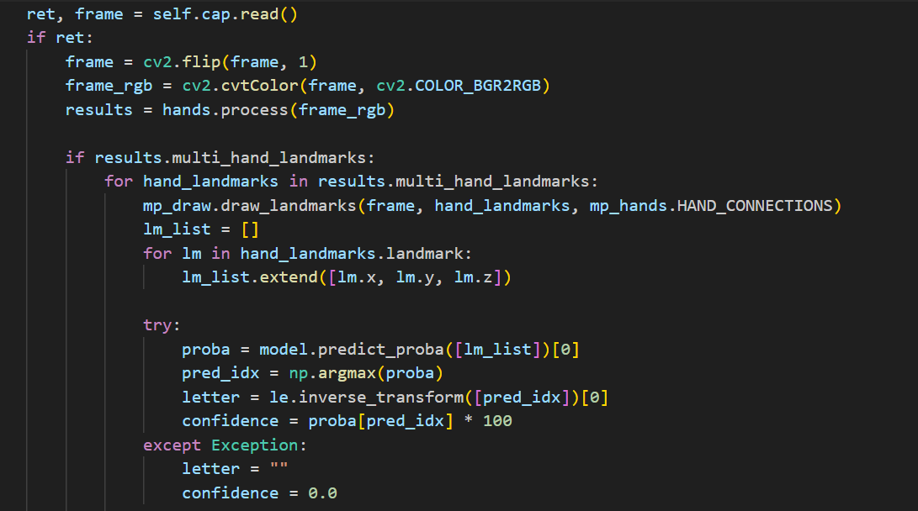

Explanation:
This module handles live camera input, applies real-time landmark detection, and classifies gestures into letters (A–Z). The accuracy and FPS values are displayed dynamically on the right-hand sidebar of the GUI.

Word Formation and Suggestions

Objective:
To form meaningful words by combining continuously detected letters and to provide AI-powered word suggestions.

Implementation Details:
- Libraries used: nltk, collections
- Data Sources: NLTK words corpus and brown corpus for training bigram-based suggestions.
- Process:
  - Detected letters are appended into words.
  - The system uses bigram probabilities to predict likely next words.
  - Suggestion buttons dynamically update based on the current input.
Sample Code Snippet:

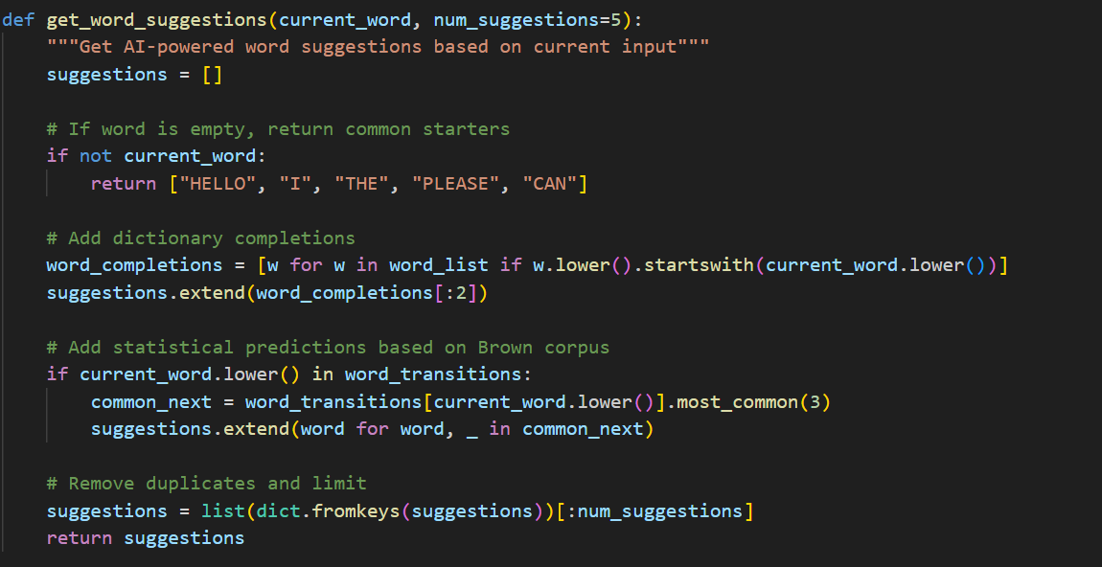

Explanation:
This function predicts possible next words or completions using both dictionary lookup and statistical corpus predictions, making communication faster and more intuitive for users.

Multi-Language Translation

Objective:
To translate the detected or formed English sentence into multiple languages using Google Translate API.

Implementation Details:
- Library used: googletrans
- Supported Languages: English, Hindi, Tamil, Telugu, Marathi
- Process:
  - The user selects a target language from the dropdown.
  - The current sentence is translated into the selected language in real-time.
  - The translated text is displayed in the GUI.

Sample Code Snippet:

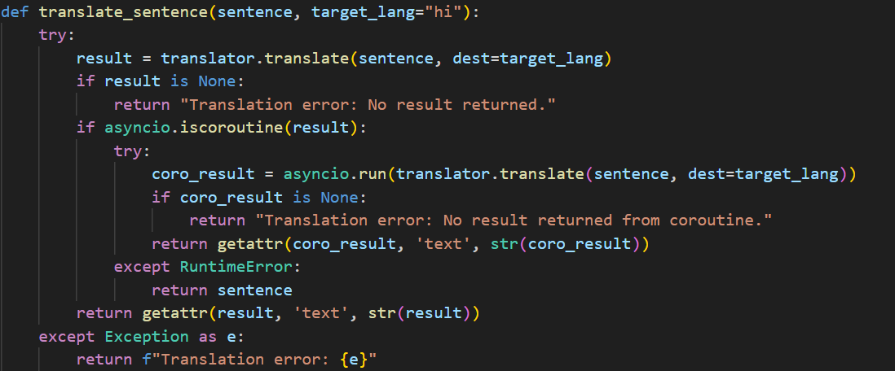

Explanation:
The translator module ensures multi-language accessibility, making the system inclusive for users speaking different regional languages.

Text-to-Speech Output

Objective:
To convert the recognized or translated sentence into audio output.

Implementation Details:
- Libraries used: gtts, playsound, tempfile
- Process:
  - Uses Google Text-to-Speech (gTTS) to synthesize speech in the selected language.
  - The generated audio file is temporarily stored and played automatically.
  - After playback, the temporary file is deleted to save memory.

Sample Code Snippet:

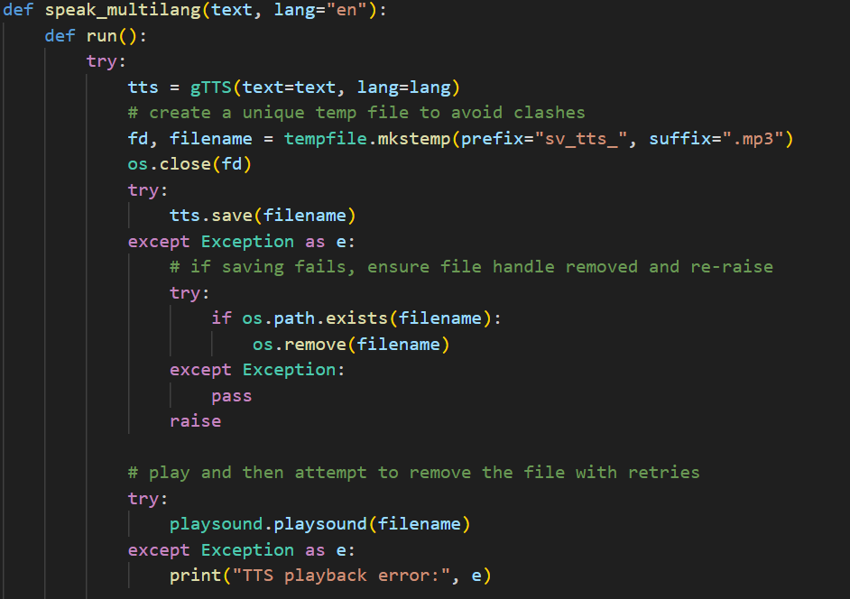

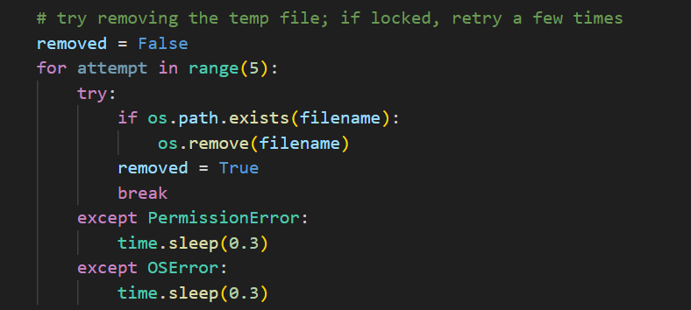

Explanation:
This feature gives auditory feedback to users, helping them listen to translated or recognized text and aiding in language learning and accessibility for non-verbal users.

Graphical User Interface (GUI)

Objective:
To provide an interactive and visually appealing interface for users to interact with all features seamlessly.

Implementation Details:
- Library used: tkinter, PIL
- Windows Implemented:
  - StartupWindow: Displays a dynamic video background and “Start Live Interpreter” button.
  - LiveWindow: Displays live camera feed, recognition results, translation controls, and suggestions.
- Additional UI Effects:
  - Animated rainbow-colored title.
  - Progress bar for confidence level.
  - Real-time FPS counter.

Sample Code Snippet:

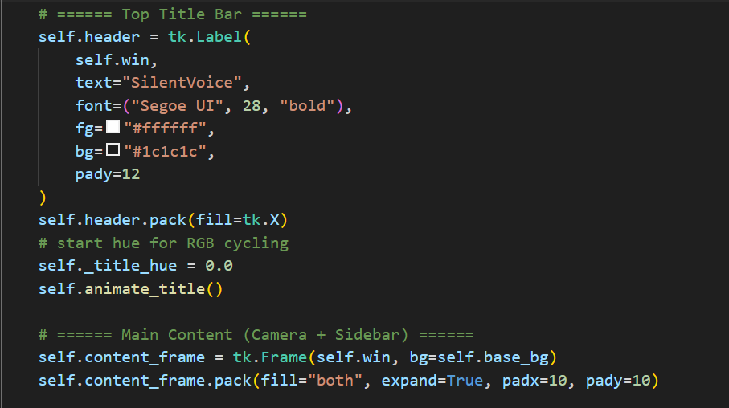

Explanation:
The interface makes the system user-friendly, real-time, and visually engaging, integrating all modules under one interactive platform.

Demo Screenshots
4.1 Training Letter-‘A’
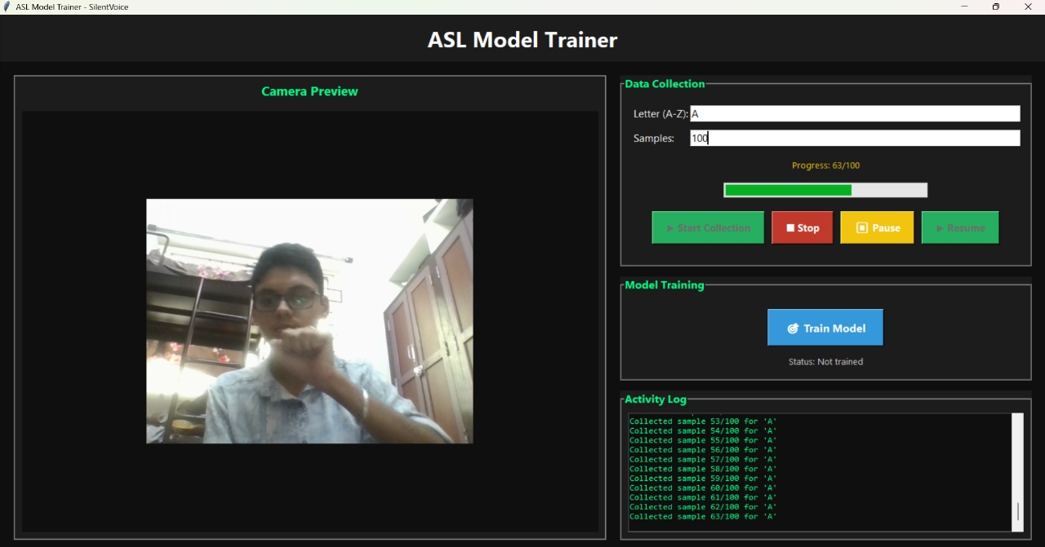

4.2 Collected 100 samples for letter ‘A’

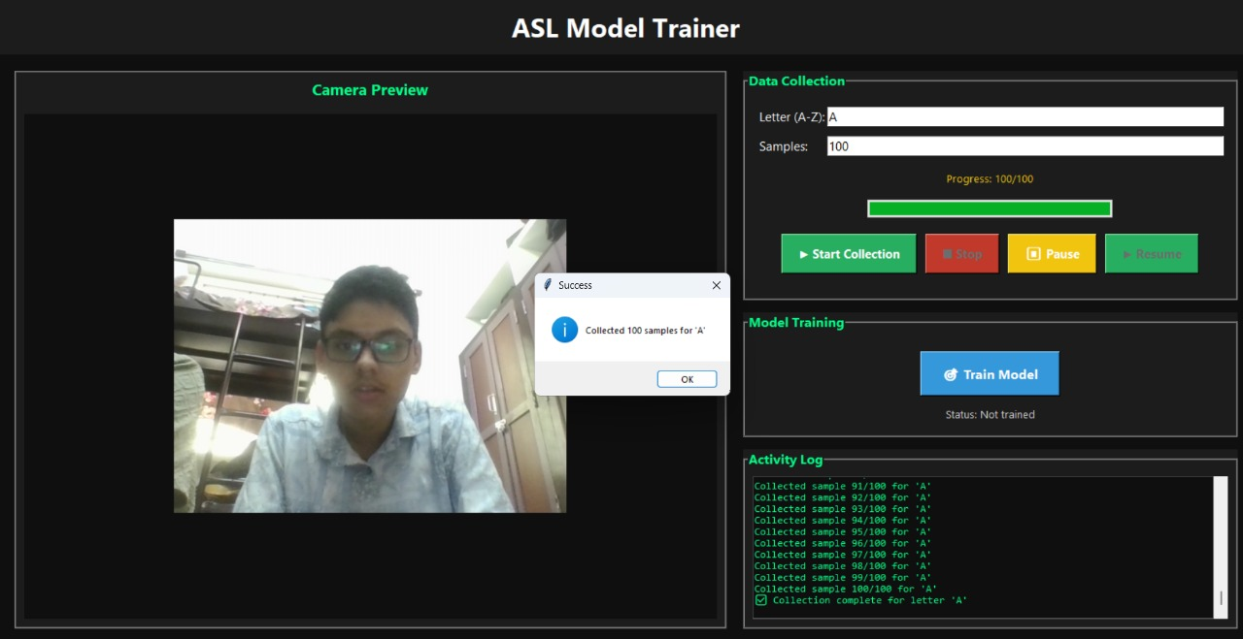

4.3 Training letter-‘B’

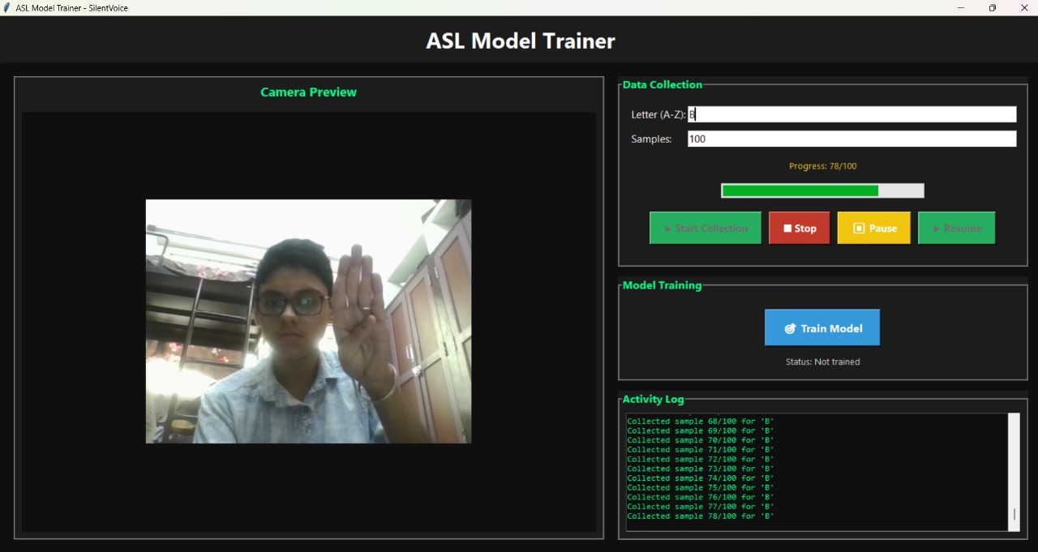

4.4 Collected 100 samples for letter ‘B’

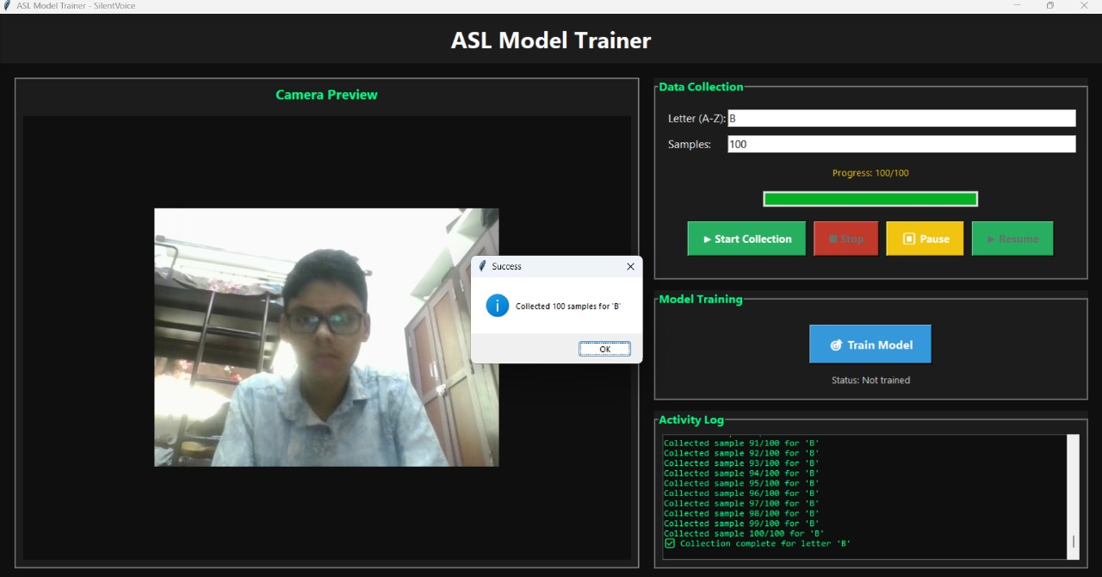

4.6 Opening runmodel.py file

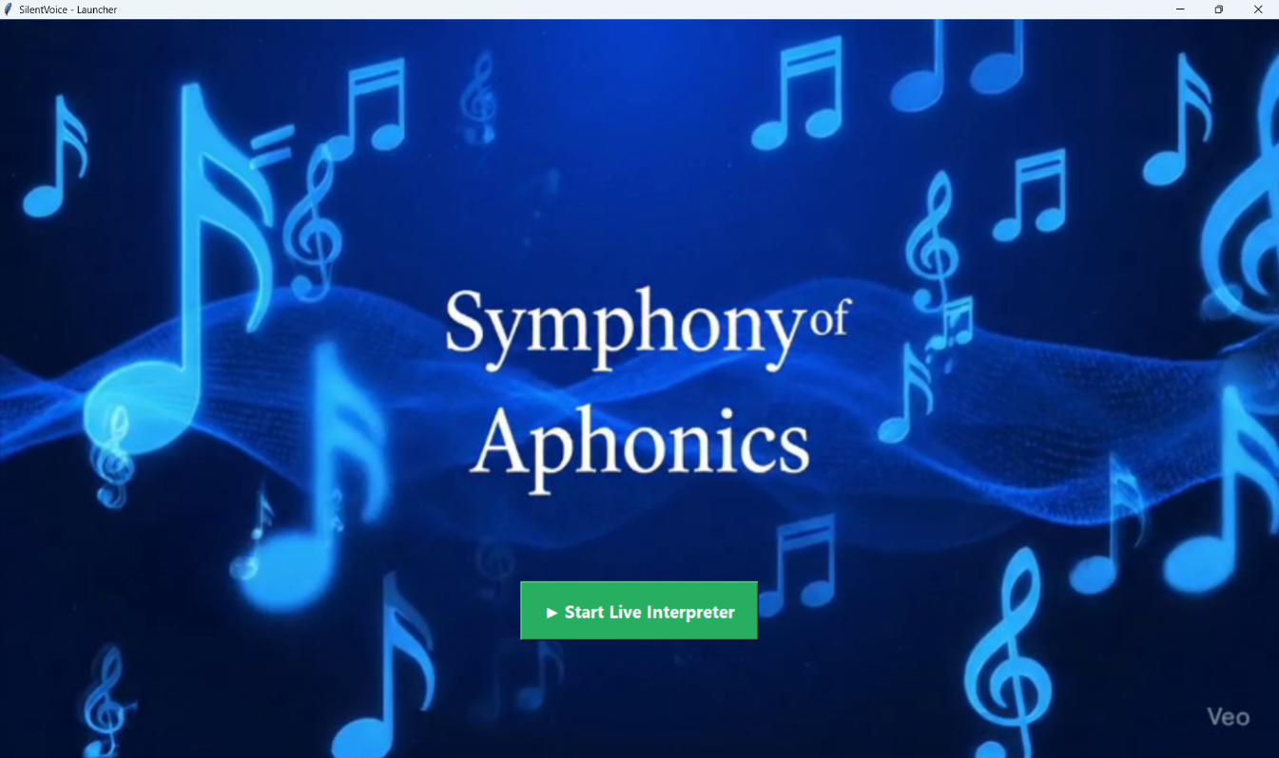

4.5 Trained letter ‘C’ & ‘D’ and displaying the word ‘BAD’

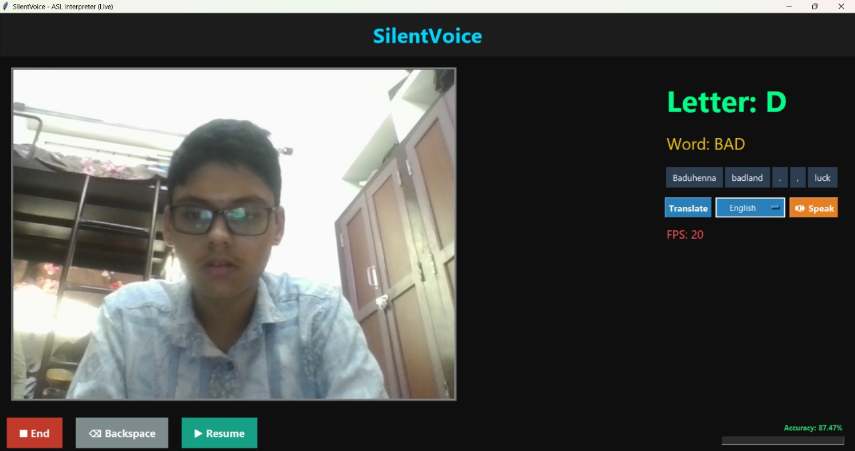

4.6 Translated the word ‘BAD’ to Hindi

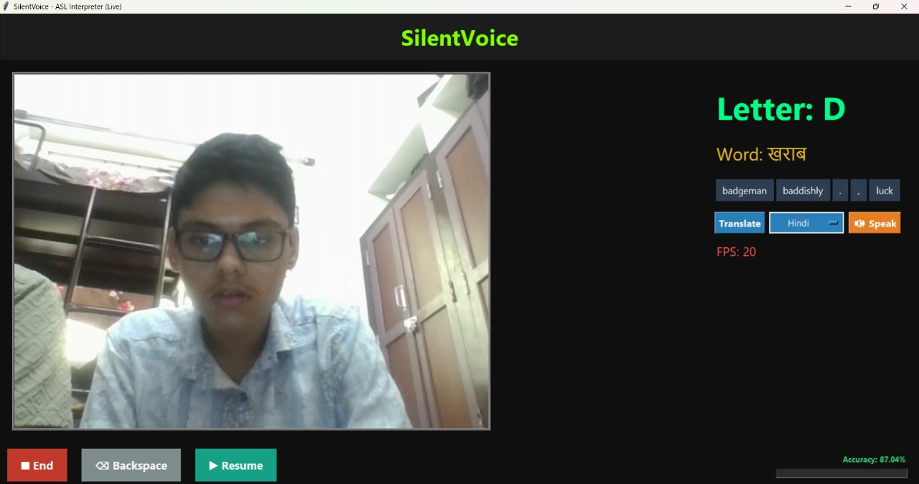

4.7 Translated the word ‘BAD’ to Telugu

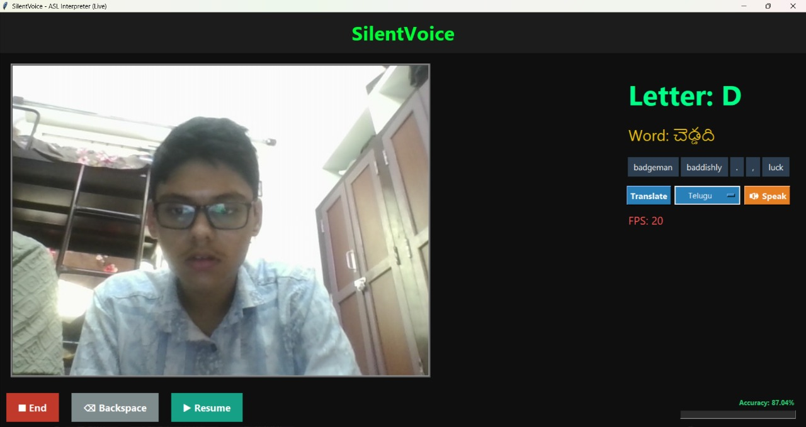

5. Conclusion
The SilentVoice project demonstrates the use of AI and computer vision in promoting inclusive communication. By integrating MediaPipe’s hand landmark detection, neural network classification, and language translation, the system can successfully convert sign gestures into meaningful text and speech. Future developments may include gesture-based word recognition, mobile app integration, and support for multiple sign languages.

- GitHub Link
GitHub URL

